Perform Moving of an Image from One Place to Another
Code
import cv2
import numpy as np
from google.colab.patches import cv2_imshow
from google.colab import files
uploaded=files.upload()
image_path=list(uploaded.keys())[0]
image=cv2.imread(image_path)
if image is None:
print("Error: Image not found")
else:
rows,cols=image.shape[:2]
matrix=np.float32([[1,0,50],[0,1,30]])
moved_image=cv2.warpAffine(image,matrix,(cols,rows))
print("Original Image")
cv2_imshow(image)
print("Moved Image")
cv2_imshow(moved_image)
Input Image
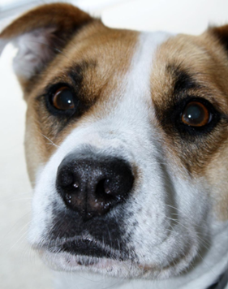
Output Image
Moved Image
